ZAYNE AMASON: IMMERSIVE INSTALLATIONS & INTERACTIVE DESIGN
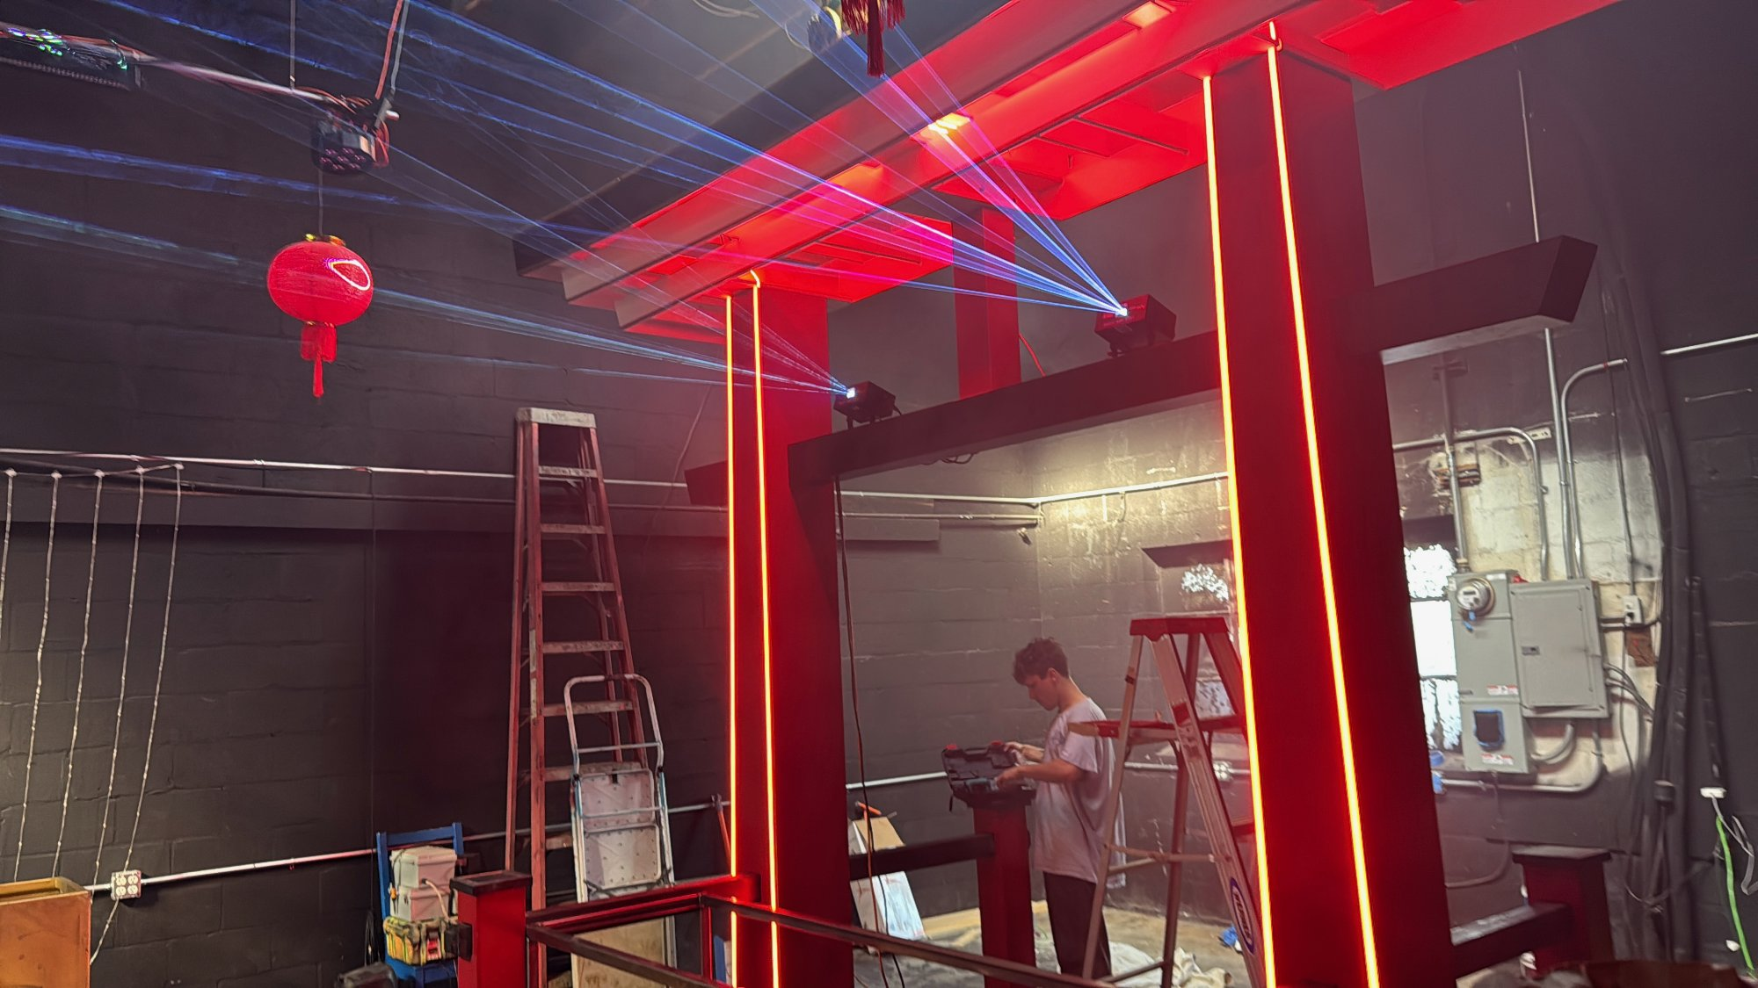 | Immersive Installation | Date: 2024 | Artist: Zayne Amason - Collaborative with Corey Smith  Title: Neon Torii | Location: The Money Cat, Los Angeles, CA  Commissioning Entity: The Money Cat  Dimensions: Approximately 10 ft tall x 8 ft wide x 3 ft deep  Materials: Welded steel frame, integrated LED channel strips, synchronized laser array, powder coat finish  Description: A modernized torii gate functioning as a DJ stage. The structure features edge-lit LED channels and overhead laser effects, creating an immersive threshold for nightclub attendees.

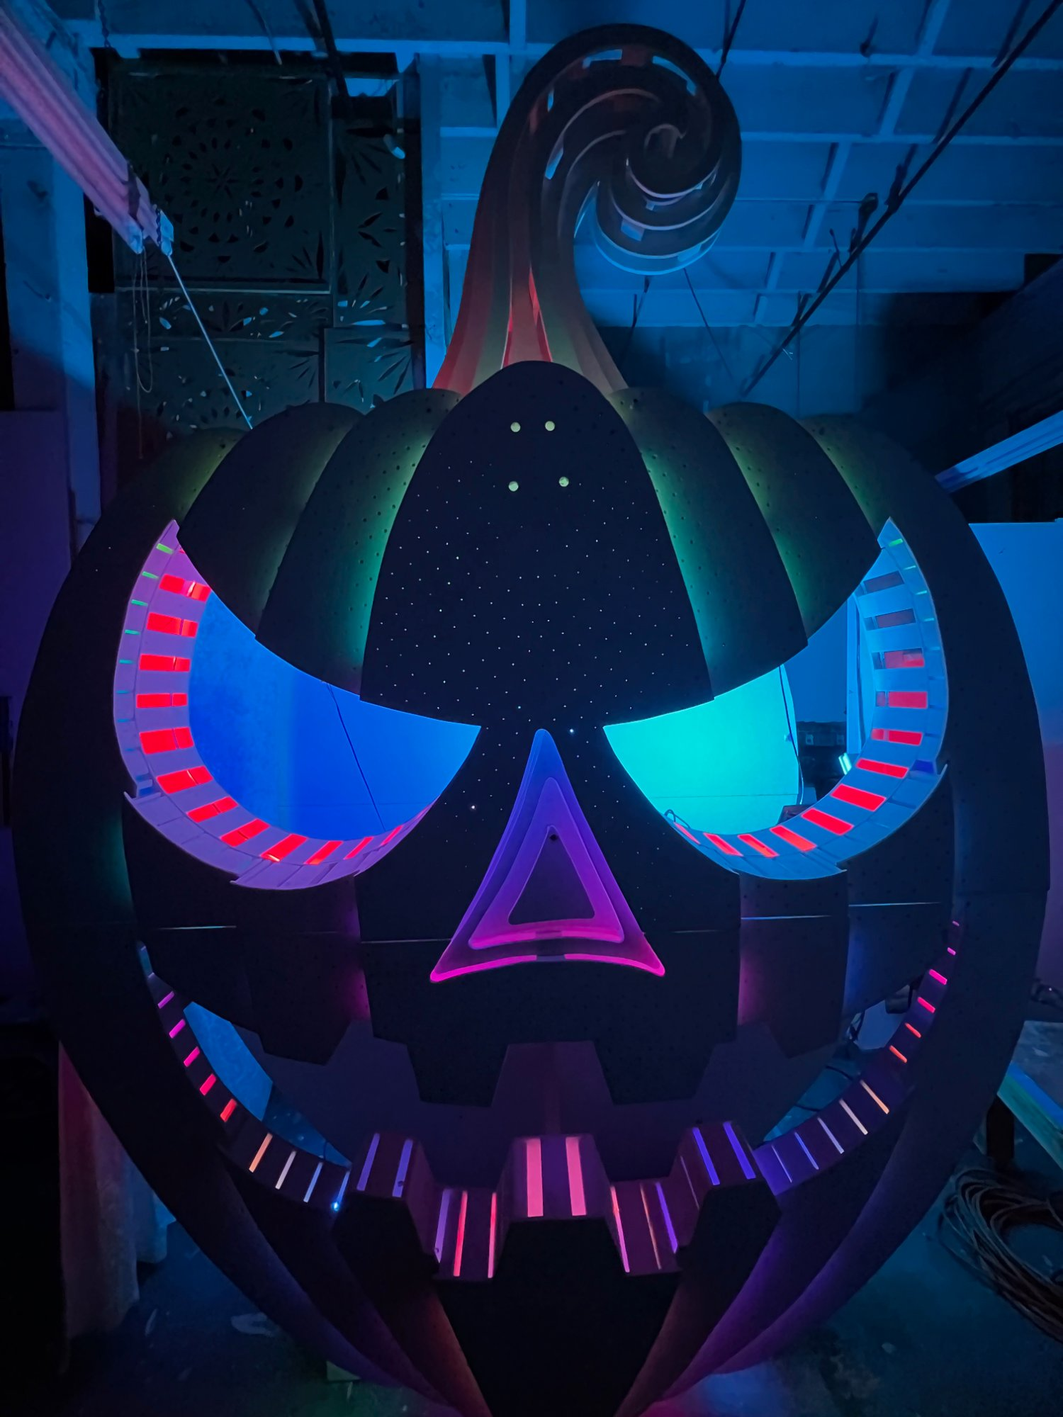 | Sculptural Installation | Date: 2024 | Artist: Zayne Amason - Collaborative with Corey Smith  Title: Jack | Location: Various Locations, Los Angeles, CA  Commissioning Entity: Private Commission  Dimensions: Approximately 8 ft tall x 6 ft wide x 4 ft deep  Materials: CNC-cut plywood ribs, perforated wood skin, addressable LED arrays  Description: A large-scale jack-o-lantern photobooth with segmented LED features in the eyes, nose, and mouth. The interior includes a star-field effect through perforated panels.

 | Immersive Environment | Date: 2024 | Artist: Zayne Amason - Collaborative with Corey Smith  Title: Bunny Portal | Location: Los Angeles, CA  Commissioning Entity: Burning Man / Private Venue  Dimensions: Portal 9 ft tall x 7 ft wide; mushrooms 7-10 ft tall  Materials: CNC-cut plywood, welded steel armatures, faux fur trim, addressable LEDs, acrylic diffusion panels  Description: An immersive walkthrough environment and DJ stage originally designed for Burning Man, later relocated to a nightclub. Features an oversized rabbit-ear portal flanked by glowing mushroom sculptures.

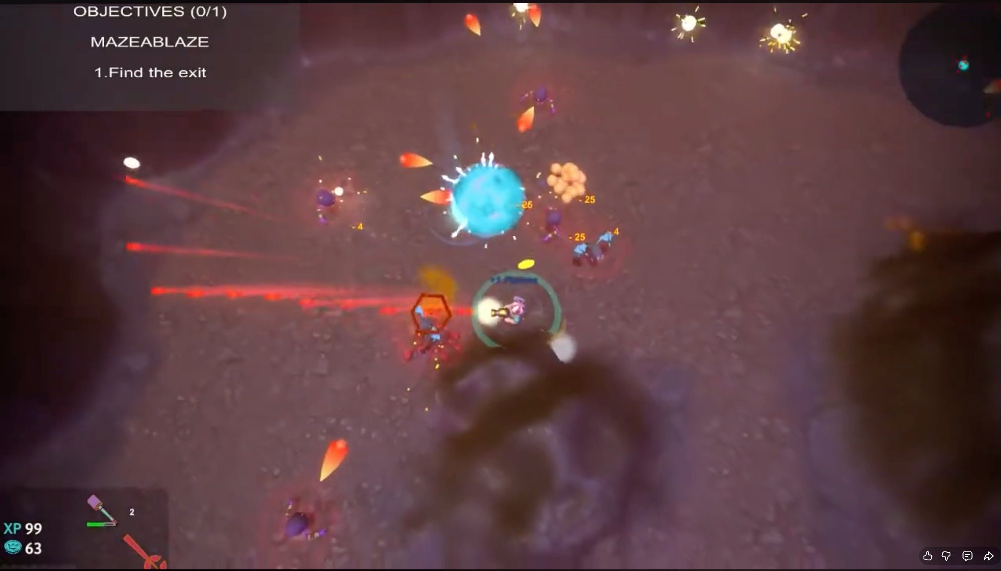 | Game Design | Date: 2021 | Artist: Zayne Amason - Solo  Title: Steve J Savage vs. Aliens | Location: PC  Commissioning Entity: Full Sail University (Academic Project)  Dimensions: Top-down action shooter  Materials: Unity Engine, custom sprite work, procedural level generation  Description: Earth lost. Humanity scattered. One man with too many guns and zero quit. Steve J Savage vs. Aliens drops players into a bullet-hell alternate universe overrun by mutants and extraterrestrial hostiles. Fast, loud, and unapologetically violent - a love letter to arcade shooters with modern firepower.

